

**Mathematics Specialist**

**Unit 3**

**2017**

**TEST 4: Differentiation and Integration**

**Student name:** _______________________  **Teacher name:** _______________________

**SOLUTIONS**

**Time allowed for this task: *45 minutes***, in class, under test conditions

Calculator-Assumed

**Materials required:**

Standard items: Pens (blue/black preferred), pencils (including coloured), sharpener, correction fluid/tape, eraser, ruler, highlighters, SCSA Formula Sheet.

Classpad Calculator and Scientific Calculator.

Special items: Drawing instruments, templates

**Marks available: 44 *marks***

**Task weighting: 8%**

Question 1 (6 marks)

Determine for each of the following:

(3 marks)

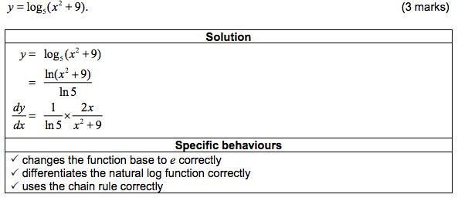

(b) and simplifying in terms of (3marks)

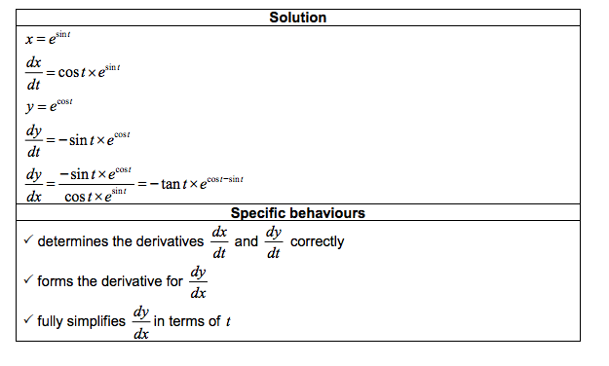

Question 2 (7 marks)

Evaluate exactly:

(a) ) (4 marks)

(b) (3 marks)

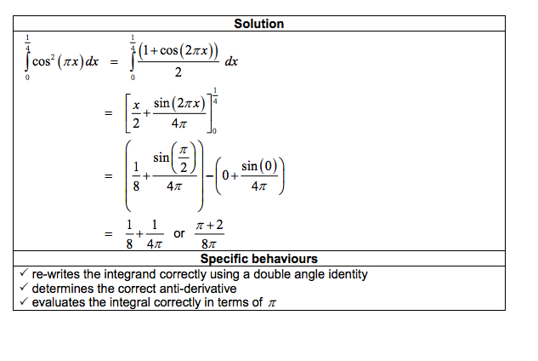

Question 3 (4 marks)

Use the substitution 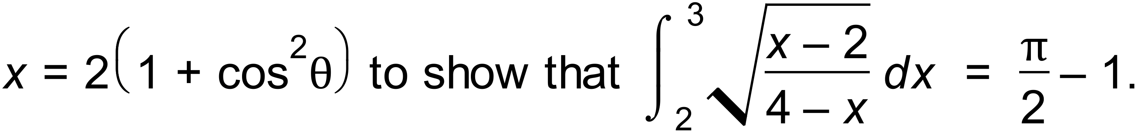

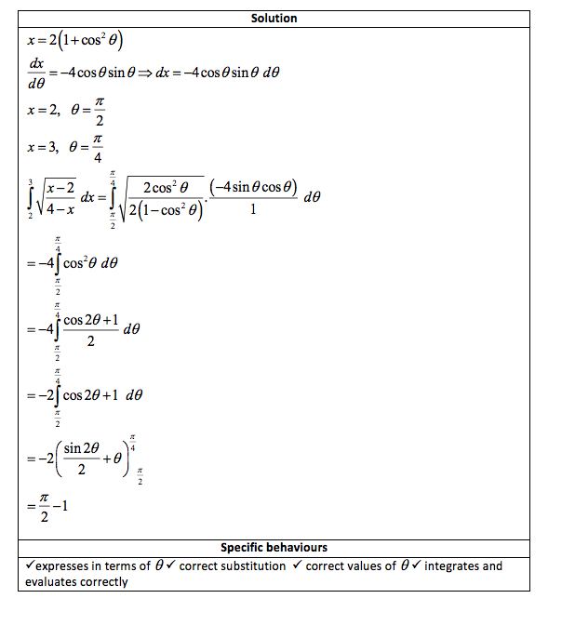

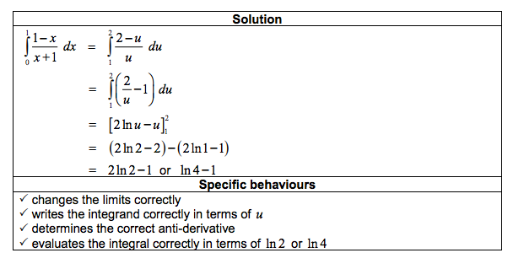

Question 4 (3 marks)

(a) Find the equation of the tangent to the curve  at the point (1, -2).

(3 marks)

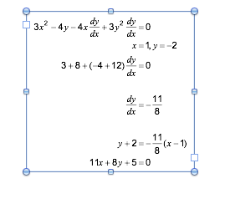

**Question 5 (4 marks)**

(a) Using partial fractions, or otherwise, determine .

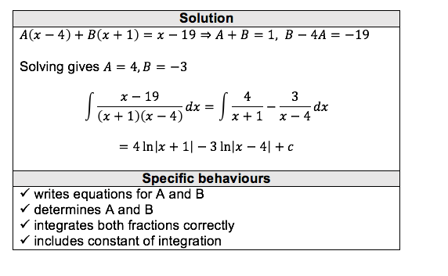

Calc assumed

Question 6 (7 marks)

The graph of is shown below, where and A is the smallest root of .

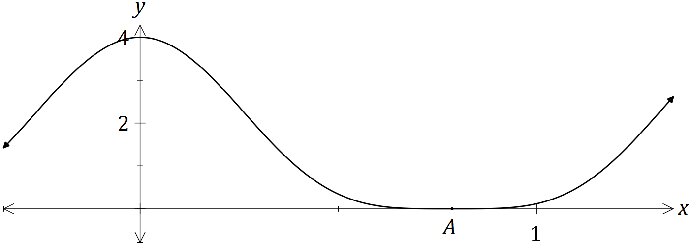

(a) Show that . (3 marks)

|  |
| --- |
| **Solution** |
|  |
| **Specific behaviours** |
| ✓ uses double angle identity  ✓ expands and uses identity again  ✓ simplifies as required |

(b) Hence determine . (2 marks)

|  |
| --- |
| **Solution** |
|  |
| **Specific behaviours** |
| ✓ uses result from (a) to integrate  ✓ obtains correct result, including constant |

(c) Determine the exact volume of the solid generated when the region bounded by , and is rotated through 360° about the x-axis.

(2 marks)

|  |
| --- |
| **Solution** |
| cubic units |
| **Specific behaviours** |
| ✓ writes integral  ✓ evaluates integral in exact form |

**Question 7 (5 marks)**

A four-metre-long water tank, open at the top, is in the shape of a triangular prism. The triangular face is a right isosceles triangle with congruent sides of one metre length.

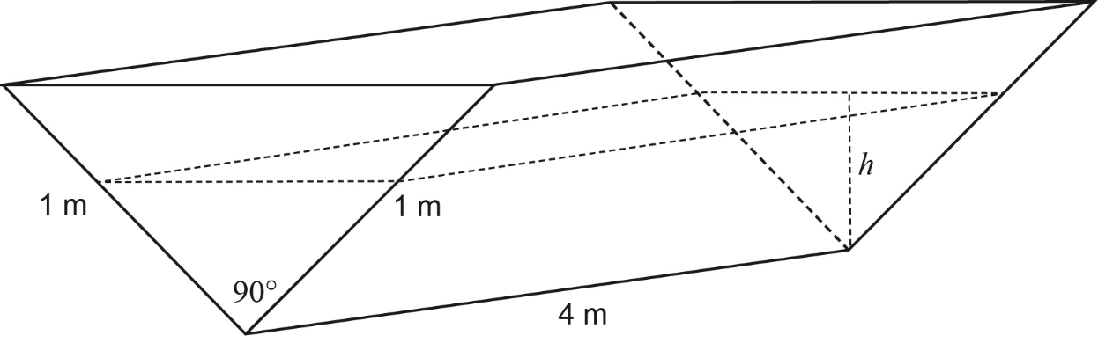

Initially the tank is completely full with water, but it develops a leak and loses water at a constant rate of 0.08 cubic metres per hour.

Let *h =* the depth of water, in metres, in the tank after *t* hours.

(a) Show that the volume of water in the tank *V* cubic metres, is given by the expression

(2 marks)

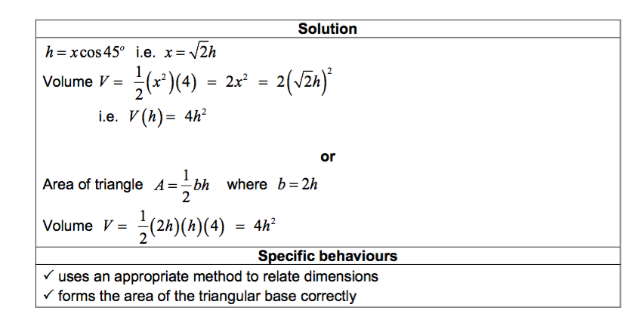

(b) Determine the rate of change of the depth, correct to the nearest 0.01 metres per hour,

when the depth is 0.6 metres. (3 marks)

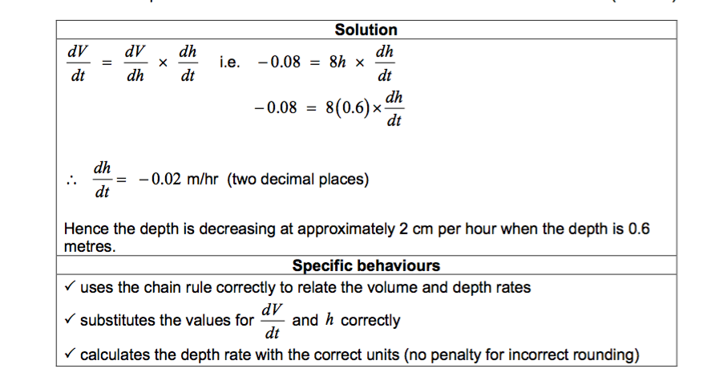

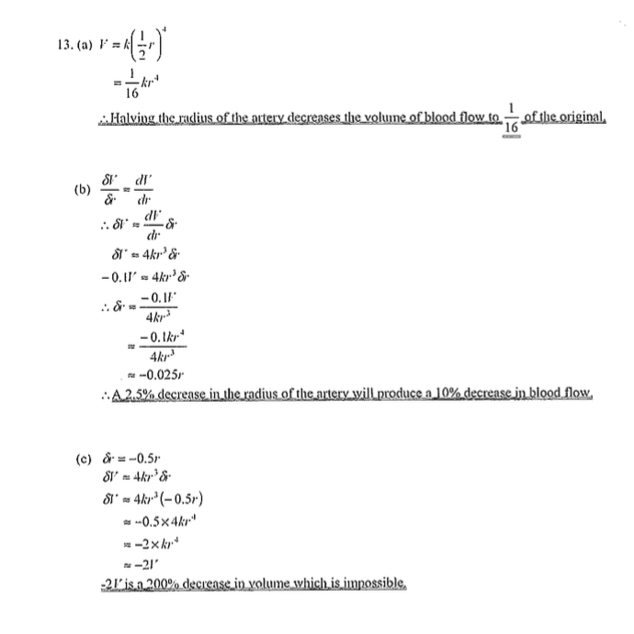**Question 8 (10 marks)**

(2 marks)

(5marks)

(3 marks)